Operational Apprenticeship Opportunities

Here at Marlborough Highways, we are looking for individuals who are keen to start their career in the highways industry to join our team as apprentices, covering a wide area of the business including:

- Highways Operatives
- Surfacing
- Street Lighting
- Traffic Management

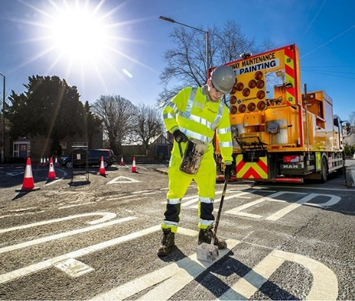
Starting with some wide exposure throughout the company, you will learn all about what we do and the way we work, before specialising in your chosen area.
Here at Marlborough, we really value our apprentices and pay a minimum of the National Living Wage company wide, as well as offering some great benefits and a fantastic working environment.
Our apprenticeship roles are based across our depots and sites in Essex and London.
Apprenticeship Entry Requirements and Overview

- 6 hours per week for Off the Job Training
- 12 -24-month duration (course dependant)
- In-house support and development
- Assessor visits take place online and in-person.
- Build a portfolio of evidence throughout programme.
- Fully funded through Marlborough Highways

If you haven’t achieved GCSE in English and Maths at Grade 4/Grade C you will be supported to achieve this as part of the apprenticeship programme.

Highways Maintenance Skilled Operative Apprenticeship

A Highways Maintenance Skilled Operative will work on rural and urban roads (not including motorways) to repair damaged surfaces, using hand and power tools and pedestrian plant machinery. They work as part of a team carrying out the repairs and individually, when preparing the area for repair.

Lead Traffic Management Operative

A Lead Traffic Management Operative (LTMO) is responsible for the coordination, installation, maintenance and removal of Temporary Traffic Management (TTM) equipment and systems.
LTMOs are responsible for setting up TTM for construction and maintenance works, public events (such as marathons and shows) and emergency incidents.

Road Surfacing Operative Apprenticeship

Road Surfacing Operatives (RSO) are responsible for the surfacing, resurfacing and improvement of
the public and privately owned highway network, covering all road types from motorways to residential streets.
RSOs work as part of a team, known as a gang, of between 8 and 14 people directed by a foreman and/or supervisor.
Operatives perform multiple roles within the gang including machine driver, machine operator, roller driver, rake hand, planer driver, and planer operator.

LGV/HGV Driver Apprenticeship

The role of an LGV Driver is to drive large goods vehicles, which are vehicles with a Gross Combined
Weight of over 7500kg and include Articulated and Draw Bar vehicles, in a safe and fuel-efficient manner.
LGV drivers will be responsible for maintaining the integrity of the load and vehicle by applying correct procedures for load restraint, performance and conduct on the road, fuel efficient driving, vehicle defect checks, complying with all traffic legislation.

Highway Electrical Maintenance + Installation Operative

A Highway Electrical Maintenance and Installation Operative is responsible for Installing and servicing electrical support structures, equipment and systems on roads and motorways.
The individual is a multi-skilled operative able to carry out both the installation of equipment (e.g.
street lighting columns, traffic signal poles) and the maintenance of that equipment (e.g. correcting faults when equipment is non-operational, changing lamps upon or close to failure).

About Marlborough Highways

Marlborough is a dynamic, independent civil engineering company with 30 years’ experience in every aspect of traditional and contemporary civil engineering work.
We have a pool of over 380 multi-skilled, longstanding staff, and our own dedicated in-house Project Managers. Members of our leadership team get involved from day one and are always on-hand to provide exceptional customer care.
We are a multi-discipline contractor, specialising in full-service highway and public space maintenance, improvement, and construction; delivering services to London Boroughs, Local Authorities, and the supply chain.

How do I find out more?

Please apply on our website to find out more about the apprenticeships we offer and one of the team will be in touch!

